**FITNESS MANAGEMENT APPLICATION**

### PROJECT REPORT

#### Submitted by

**Vanshita Kapoor**

**(2110993882-G2)**

**BE-CSE (Artificial Intelligence)**

***Guided by***

**Dr. Vandana Sood**

**CHITKARA UNIVERSITY INSITUTE OF ENGINEERING & TECHNOLOGY**

**CHITKARA UNIVERSITY, RAJPURA**

**JULY 2022**

**Table of Contents**

1. **Acknowledgement…………………………………………………………………..3**
2. **Abstract……………………………………………………………………………...4**
3. **List of Tables………………………………………………………………………...5**
4. **List of Figures……………………………………………………………………….5**
5. **Chapters………………………………………………………………………….6-20**
   1. Introduction **.…………………………………………………………………………6**
   2. Problem Formulation **………………………………………………………………...7**
   3. Proposed Solution / Methodology **……………………………………………………7**
   4. Flowchart/ system flow diagram **…………………………………………………….8**
   5. Software & Hardware requirement **………………………………………………….9**
   6. Code (Maximum 5 to 6 pages) **.............................................................................10-16**
   7. Results (Screenshot) **............................................................................................17-19**
   8. Conclusion **………………………………………………………………………….20**
6. References…………………………………………………………………………..**21**
7. ACKNOWLEDGEMENT

With immense please **I**, **Ms. Vanshita Kapoor** presenting “**Fitsum-One stop destination where you can commit to a new you**” project report as part of the curriculum of ‘BE-CSE (AI)’.

I would like to express my sincere thanks to **Dr. Kamal Deep Garg and Dr. Vandana Sood**, for their valuable guidance and support in completing my project.

I would also like to express my gratitude towards our dean **Dr. Sushil Kumar Narang** for giving me this great opportunity to do a project on **Health & Fitness Website**. Without their support and suggestions, this project would not have been completed.

Signature………..

Name: Vanshita Kapoor

Roll No: 2110993882

1. **ABSTRACT**

FitSum is aimed at developing a web application with different functions using HTML, CSS and Javascript. This allows you to easily monitor your health & fitness and easily keeps track of your progress. It allows you to set realistic goals like when you begin exercising, you must set realistic goals. You must set targets as to how much progress should be done in how much time. Moreover, it operates at the convenience of just one click so you can carry your dietitian in your pocket now.

One can also monitor his/her diet everyday and keep a record of the calories consumed and food taken throughout the entire week. The user can also reference to some free youtube videos for workout which might be a tedious task for some to search and look for the good videos. So, this web application is basically designed using different technologies such as HTML, CSS and Javascript in order to help the users achieve a healthy and a better lifestyle.

1. **LIST OF TABLES**

|  |  |
| --- | --- |
| **TABLE NUMBER** | **TABLE CONTENTS** |
| 1.1 | Hardware Requirements |
| 1.2 | Software Requirements |

1. **LIST OF FIGURES**

|  |  |
| --- | --- |
| **FIGURE NUMBER** | **FIGURE CONTENTS** |
| Fig 1.1 | Flowchart |
| Fig 1.2 | Box to fill details of meal description and calories consumed screenshot |
| Fig 1.3 | Calorie Tracking Chart Screenshot |
| Fig 1.4 | Button to calculate BMI screenshot |
| Fig 1.5 | Box wherein details of user like height and weight are entered screenshot |
| Fig 1.6 | Workout guide page screenshot |
| Fig 1.7 | Login Page screenshot |

1. **CHAPTERS**
   1. **Introduction**

The objective of a fitness website is to provide the user with instructions and examples of one or more types of exercise, physical activity, nutritional programs, or some other fitness topic at the convenience of just one click.

It is used to track calories, provide a workout guide and also calculates the Body Mass Index of the user to keep a track of their performance.

It is basically designed to connect the user to a platform in order to help with areas of concerns when using a specific fitness routine or just generally with workouts.

Those people who are mostly indulged in internet and don’t get time to look after their health can invest more time upon their health through this. A health & fitness system helps you with different parameters and lead to an all-rounder growth of an individual in terms of health.

It is a type of website that is equipped with various services such as a BMI Calculator, Calorie Tracker and a Workout Guide.

* 1. **Problem Formulation**

In fast pace moving world where everything is changing the very next second doesn’t matter in which professional field or background you belong but as it is wisely said “Health is wealth”!!! Obviously, you have heard it a thousand times but as we grow older we often forget to realize the importance of health in our lives.

So this website will prove to be of great help to people who want everything done for them on just one click in their lives.

* 1. **Proposed Solution / Methodology**

This website provides an interesting way to get started with the very boring term “dieting” as we already know “FITNESS START WITH WHAT WE EAT AND IN WHAT MANNER ”. To maintain a good health one needs to constantly keep on looking after your fitness throughout your life irrespective of at what stage you are in your life. So, I hereby bring to you a revolutionary health & fitness website, “FitSum” that is used to record and estimate number of calories we need to consume daily. This website can also provide guidelines for gaining or losing weight.

This health and fitness website is made by using HTML, CSS and Javascript which helps the users to keep a track of their diet, do workout regularly without going to a trainer, calculate their body mass index(BMI) which also tells how much weight one needs to lose or gain in order to maintain a healthy BMI and you can even keep a track of what meal you have taken and much calories you have consumed.

* 1. **Flowchart/ system flow diagram**

**Figure 1.1** Flowchart

**LOGIN/SIGN-UP**

**FITSUM- A REVOLUTIONARY HEALTH & FITNESS WEBSITE**

**WORKOUT GUIDE**

**CALORIE TRACKER**

**BMI CALCULATOR**

**HOMEPAGE**

**Button which opens a box to enter the data & then BMI is calculated & displayed.**

**This data is then shown in a chart where you can keep a record all your meals**

**“Add meal” button which opens a box to enter meal description and calories consumed**

**JAVASCRIPT**

**CSS**

**HTML**

**END**

* 1. **Software & Hardware requirement**

**Table 1.1** Hardware Requirements

|  |  |
| --- | --- |
| **HARDWARE REQUIREMENTS** | **MINIMUM** |
| Hard Disk | 500 MB |
| Monitor | Higher Resolution monitor |
| Memory | Minimum - 512MB  Recommended - 1GB |
| Processor | Minimum: x32 bit or x64 bit (1.4 GHz)  Recommended: 2.0GHz or faster |

**Table 1.2** Software Requirements

|  |  |
| --- | --- |
| **SOFTWARE REQUIREMENTS** | **MINIMUM** |
| Web Browser | Chrome, Internet Explorer, Opera, Microsoft Edge etc. |
| Coding Platform | Visual Studio Code |
| Coding Languages | HTML 5.0, CSS and JavaScript |

* 1. **Code (Maximum 5 to 6 pages)**

**HTML code for Home page**

<!DOCTYPE html>

<html lang="en">

<head>

<meta charset="UTF-8">

<meta http-equiv="X-UA-Compatible" content="IE=edge">

<meta name="viewport" content="width=device-width, initial-scale=1.0">

<link rel="icon" href="images/healthy.png">

<link href="https://cdn.jsdelivr.net/npm/bootstrap@5.1.0/dist/css/bootstrap.min.css" rel="stylesheet" integrity="sha384-KyZXEAg3QhqLMpG8r+8fhAXLRk2vvoC2f3B09zVXn8CA5QIVfZOJ3BCsw2P0p/We" crossorigin="anonymous">

<link rel="stylesheet" href="style/index.css">

<title>FitSum</title>

</head>

<body>

<nav class="navbar navbar-expand-lg navbar-light" style="background-color: #e3f2fd;">

<a class="navbar-brand" href="#">

<img src="images/healthy.png" width="30" height="30" class="d-inline-block align-top" alt="">

FitSum

</a>

<button class="navbar-toggler" type="button" data-toggle="collapse" data-target="#navbarSupportedContent" aria-controls="navbarSupportedContent" aria-expanded="false" aria-label="Toggle navigation">

<span class="navbar-toggler-icon"></span>

</button>

<div class="collapse navbar-collapse" id="navbarSupportedContent">

<ul class="navbar-nav ml-auto">

<li class="nav-item active">

<a class="nav-link" href="index.html">Home <span class="sr-only"></span></a>

</li>

<li class="nav-item">

<a class="nav-link" href="pages/bmi.html">BMI Calculator</a>

</li>

<li class="nav-item">

<a class="nav-link" href="pages/foodTracker.html">Calories Tracker</a>

</li>

<li class="nav-item">

<a class="nav-link" href="pages/fitness.html">Workout Guide</a>

</li>

<li class="nav-item">

<a class="nav-link" href="pages/aboutus.html">About Us</a>

</li>

</ul>

</div>

</nav>

<div class="jumbotron">

<h1 class="display-6 px-1"><b>"One stop destination where you can commit to a new you!!!"</b></h1>

<hr class="my-4">

<p class="lead"><b>We provide following support in your fat burning or gaining journey</b></p>

<hr class="my-4">

<div class="card mb-3" style="max-width: 80%">

<div class="row g-0">

<div class="col-md-4">

<img src="images/bmi.png" class="img-fluid rounded-start icons" alt="bmi icon">

</div>

<div class="col-md-8">

<div class="card-body">

<h5 class="card-title">➡ BMI Calculator:</h5>

<p class="card-text">We provide you information regarding body mass index, table and calculator for same. We also provide you information to loss or gain weight in Kilogram according to your BMI. </p>

<a type="button" href="pages/bmi.html" class="btn" style="background-color: #1f84cb;">Visit BMI Calculator</a>

</div>

</div>

</div>

</div>

<hr class="my-4">

<div class="card mb-3" style="max-width: 80%">

<div class="row g-0">

<div class="col-md-4">

<img src="images/calories.png" class="img-fluid rounded-start icons" alt="bmi icon">

</div>

<div class="col-md-8">

<div class="card-body">

<h5 class="card-title">➡ Calories Tracker:</h5>

<p class="card-text">It is really osum way of keeping track of all your eatings in entire week along with their calories. We also provide you brief insight of acute, accurate or over eating through different color display cards. </p>

<a type="button" href="pages/foodTracker.html" class="btn" style="background-color: #1f84cb;">Visit Calories Tracker</a>

</div>

</div>

</div>

</div>

<hr class="my-4">

<div class="card mb-3" style="max-width: 80%">

<div class="row g-0">

<div class="col-md-4">

<img src="images/book.png" class="img-fluid rounded-start icons" alt="bmi icon">

</div>

<div class="col-md-8">

<div class="card-body">

<h5 class="card-title">➡ Workout Guide:</h5>

<p class="card-text">We have included various types of workouts according to user requirement, they can select from full body, body part specific, walking, zumba. We target all age groups and have specific workout suggestion for oldies too. </p>

<a type="button" href="pages/fitness.html" class="btn" style="background-color: #1f84cb;">Visit Workout Guide</a>

</div>

</div>

</div>

</div>

</body>

</html>

**Javascript Code-1 for BMI Calculator**

calc = document.getElementById("bmibutton");

yourbmi = document.getElementById("yourBMI");

calcyourbmi = document.getElementById("calcYourBMI");

calc.addEventListener("click",getinfo);

function getinfo(){

weight = document.getElementById("weight").value;

localStorage.setItem("weightset",weight);

height = document.getElementById("height").value;

localStorage.setItem("heightset",height);

weightget = localStorage.getItem("weightset");

heightget = localStorage.getItem("heightset");

heightget = heightget/100;

$("#bmiModal").modal("hide");

$(".modal-body input").val("");

bmi = (weightget/(heightget*heightget)).toFixed(2);

calcyourbmi.innerHTML = 'Calculate Again';

if(bmi<16){

yourbmi.innerHTML = `Your BMI is ${bmi}. You Fall under Severe Thinness category. You should Gain 📈 ${((22-bmi)*heightget*heightget).toFixed(2)} Kilogram to maintain good Health.` ;

}

else if(bmi< 17 && bmi >= 16){

yourbmi.innerHTML = `Your BMI is ${bmi}. You Fall under Moderate Thinness category. You should Gain 📈 ${((22-bmi)*heightget*heightget).toFixed(2)} Kilogram to maintain good Health.` ;

}

else if(bmi< 18.5 && bmi >= 17){

yourbmi.innerHTML = `Your BMI is ${bmi}. You Fall under Mild Thinness category. You should Gain 📈 ${((22-bmi)*heightget*heightget).toFixed(2)} Kilogram to maintain good Health.` ;

}

else if(bmi< 25 && bmi >= 18.5){

yourbmi.innerHTML = `Your BMI is ${bmi}. You Fall under Normal category. You have healthy BMI maintain it.👍` ;

}

else if(bmi< 30 && bmi >= 25){

yourbmi.innerHTML = `Your BMI is ${bmi}. You Fall under Overweight category. You should lose 📉 ${((bmi-22)*heightget*heightget).toFixed(2)} Kilogram to maintain good Health.` ;

}

else if(bmi< 35 && bmi >= 30){

yourbmi.innerHTML = `Your BMI is ${bmi}. You Fall under Obese Class I category. You should lose 📉 ${((bmi-22)*heightget*heightget).toFixed(2)} Kilogram to maintain good Health.` ;

}

else if(bmi< 40 && bmi >= 35){

yourbmi.innerHTML = `Your BMI is ${bmi}. You Fall under Obese Class II category. You should lose 📉 ${((bmi-22)*heightget*heightget).toFixed(2)} Kilogram to maintain good Health.` ;

}

else if(bmi >= 40){

yourbmi.innerHTML = `Your BMI is ${bmi}. You Fall under Obese Class III category. You should lose 📉 ${((bmi-22)*heightget*heightget).toFixed(2)} Kilogram to maintain good Health.` ;

}

}

**JavaScript code – 2 for Calorie Tracker**

track = document.getElementById("addbutton");

track.addEventListener("click",getinformation);

function getinformation(){

day = document.getElementById("day").value;

localStorage.setItem("dayset",day);

meal = document.getElementById("meal").value;

localStorage.setItem("mealset",meal);

description = document.getElementById("description").value;

localStorage.setItem("descriptionset",description);

calories = document.getElementById("calories").value;

localStorage.setItem("caloriesset",calories)

dayget = localStorage.getItem("dayset");

mealget = localStorage.getItem("mealset");

descriptionget = localStorage.getItem("descriptionset");

caloriesget = localStorage.getItem("caloriesset");

$("#exampleModal").modal("hide");

$(".modal-body input").val("");

let dayremove = document.getElementById("day");

dayremove.selectedIndex = 0;

let mealremove = document.getElementById("meal");

mealremove.selectedIndex = 0;

if(dayget=="Sunday" && mealget=="Breakfast"){ fieldBox("bsun")}

else if(dayget=="Monday" && mealget=="Breakfast"){fieldBox("bmon");}

else if(dayget=="Tuesday" && mealget=="Breakfast"){fieldBox("btue");}

else if(dayget=="Wednesday" && mealget=="Breakfast"){fieldBox("bwed");}

else if(dayget=="Thrusday" && mealget=="Breakfast"){fieldBox("bthr");}

else if(dayget=="Friday" && mealget=="Breakfast"){fieldBox("bfri");}

else if(dayget=="Saturday" && mealget=="Breakfast"){ fieldBox("bsat");}

else if(dayget=="Sunday" && mealget=="Lunch"){ fieldBox("lsun");}

else if(dayget=="Monday" && mealget=="Lunch"){fieldBox("lmon");}

else if(dayget=="Tuesday" && mealget=="Lunch"){fieldBox("ltue");}

else if(dayget=="Wednesday" && mealget=="Lunch"){fieldBox("lwed");}

else if(dayget=="Thrusday" && mealget=="Lunch"){fieldBox("lthr");}

else if(dayget=="Friday" && mealget=="Lunch"){fieldBox("lfri");}

else if(dayget=="Saturday" && mealget=="Lunch"){ fieldBox("lsat");}

else if(dayget=="Sunday" && mealget=="Snacks"){fieldBox("ssun");}

else if(dayget=="Monday" && mealget=="Snacks"){ fieldBox("smon");}

else if(dayget=="Tuesday" && mealget=="Snacks"){fieldBox("stue");}

else if(dayget=="Wednesday" && mealget=="Snacks"){ fieldBox("swed");}

else if(dayget=="Thrusday" && mealget=="Snacks"){fieldBox("sthr");}

else if(dayget=="Friday" && mealget=="Snacks"){fieldBox("sfri");}

else if(dayget=="Saturday" && mealget=="Snacks"){ fieldBox("ssat");}

else if(dayget=="Sunday" && mealget=="Dinner"){ fieldBox("dsun");}

else if(dayget=="Monday" && mealget=="Dinner"){ fieldBox("dmon");}

else if(dayget=="Tuesday" && mealget=="Dinner"){ fieldBox("dtue");}

else if(dayget=="Wednesday" && mealget=="Dinner"){ fieldBox("dwed");}

else if(dayget=="Thrusday" && mealget=="Dinner"){ fieldBox("dthr");}

else if(dayget=="Friday" && mealget=="Dinner"){fieldBox("dfri");

else if(dayget=="Saturday" && mealget=="Dinner"){ fieldBox("dsat");}

function fieldBox(idimp){

x = document.createElement("div");

br = document.createElement("br");

if(mealget=="Lunch"||mealget=="Dinner")

{

if(caloriesget>=500&&caloriesget<=700)

{

x.style.backgroundColor = "#28a745";

}

else if(caloriesget<500)

{

x.style.backgroundColor = "#ffc107";

}

else if(caloriesget>700)

{

x.style.backgroundColor = "#dc3545";

}

}

else if(mealget=="Breakfast")

{

if(caloriesget>=300&&caloriesget<=400)

{

x.style.backgroundColor = "#28a745";

}

else if(caloriesget<300)

{

x.style.backgroundColor = "#ffc107";

}

else if(caloriesget>400)

{

x.style.backgroundColor = "#dc3545";

}

}

else if(mealget=="Snacks")

{

if(caloriesget<200)

{

x.style.backgroundColor = "#28a745";

}

else

{

x.style.backgroundColor = "#dc3545";

}

}

x.style.border = "1px solid black";

x.style.borderRadius = "5px";

x.style.boxSizing = "border-box";

x.style.padding = "2px";

x.style.height = "65px";

t = document.createTextNode(descriptionget);

x.appendChild(t);

x.appendChild(br);

t1 = document.createTextNode("Calories: "+caloriesget);

x.appendChild(t1);

x.style.fontSize = "0.9rem";

document.getElementById(idimp).appendChild(x);

}

}

* 1. **Results (Screenshot)**

**CALORIE TRACKER**

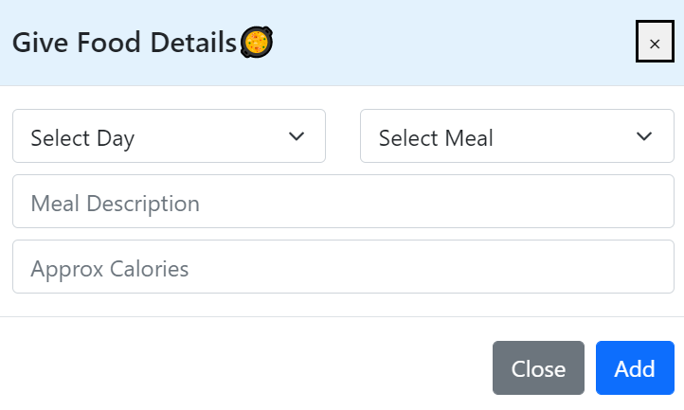

**Figure 1.2**This is the text box to write the meal description and calories in that meal.

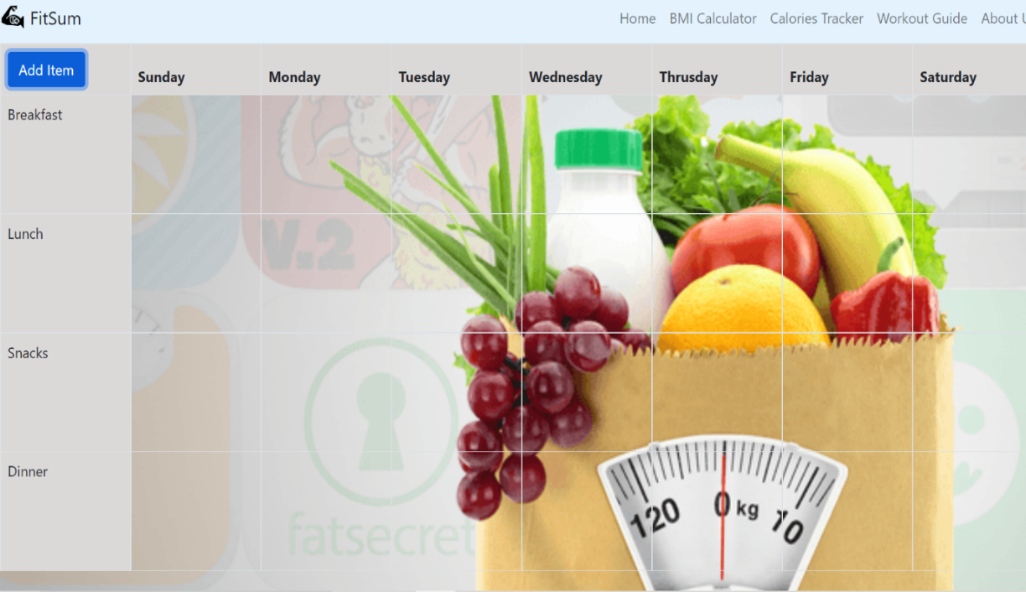

**Figure 1.3** This is the chart where food details are displayed.

**BMI CALCULATOR**

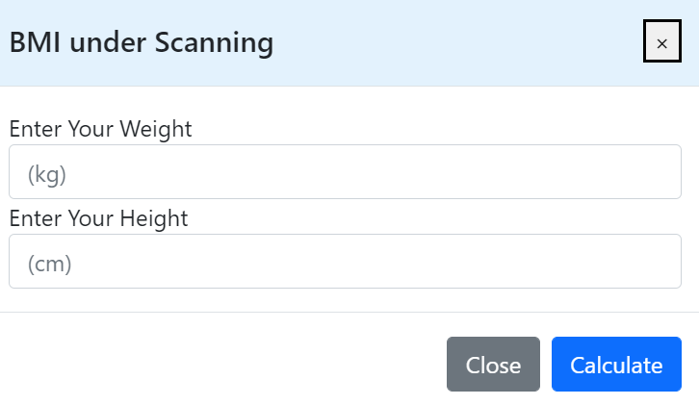

**Figure 1.4**  This the the box where you provide your details like height and weight and the BMI is shown. It also shows how much weight you need to lose or gain to maintain a healthy BMI.

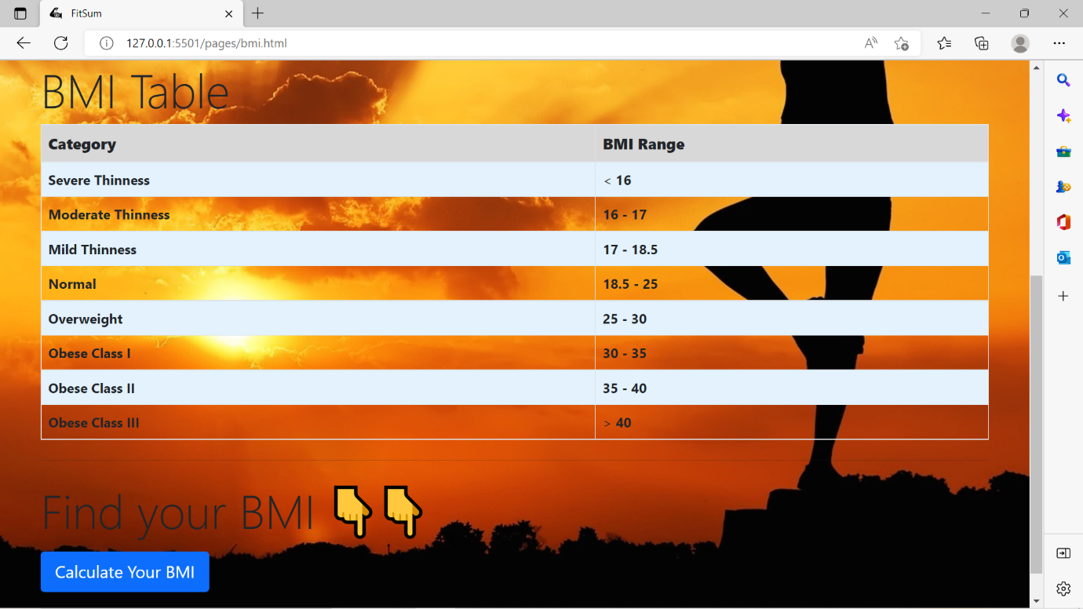

**Figure 1.5** This is the button from where the above box appears asking the details of the user and therefore calculates the BMI.

**WORKOUT GUIDE**

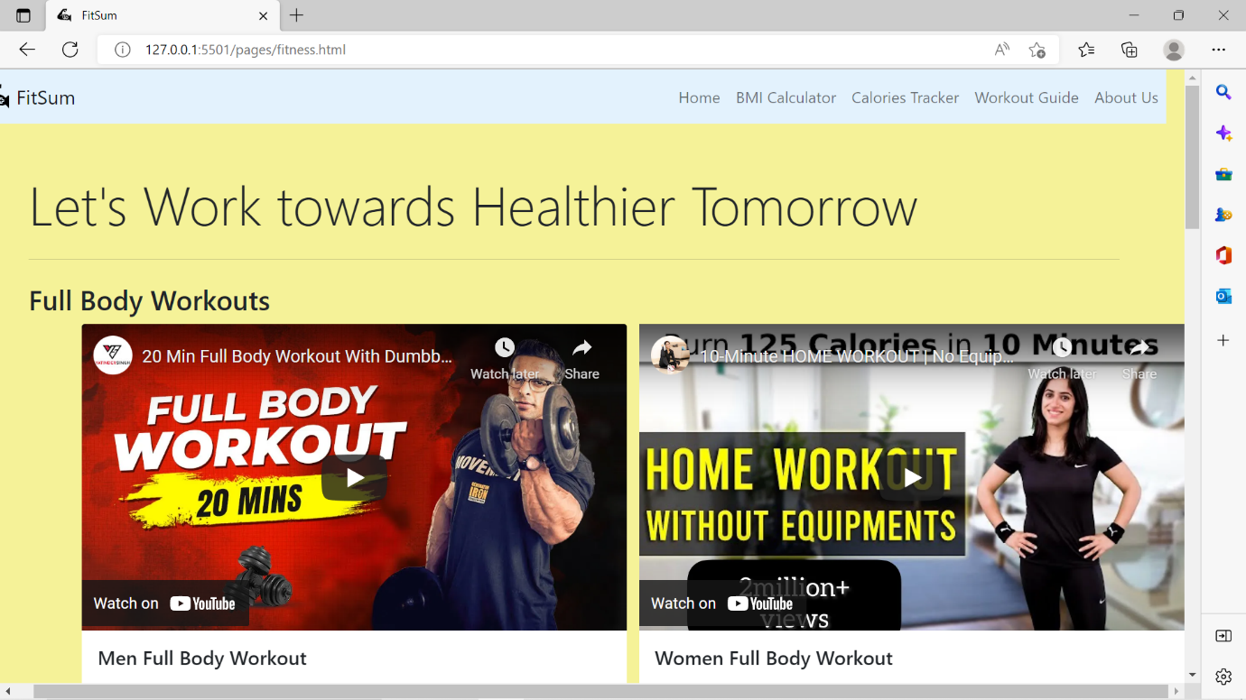

**Figure 1.6** This is the “Workout Guide” where you get the reference of some youtube videos related to diet and workout.

**LOGIN PAGE**

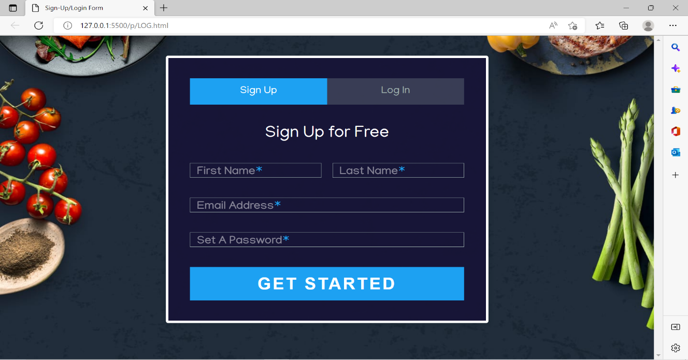

**Figure 1.7** This is the screenshot of the login/signup page.

* 1. **CONCLUSION**

FitSum is made using HTML, CSS, JavaScript. This will help the users in many ways to adapt a healthy lifestyle. In my project an attempt has been made to develop a health or fitness based website. I developed this project that helps people to be aware about their health. To establish website I have used various technologies. It is going to be of a great use especially for this generation who loves to get anything with just one click or getting the work done at their own comfort level. Users can surf the website and keep a check on their health & fitness at their own comfort place doesn’t matter where they are at their current location. Hence, it will be of a great use for almost everyone irrespective of its age group.

**6. REFERENCES**

* [**www.geeksforgeeks.com**](http://www.geeksforgeeks.com/)
* [**www.javatpoint.com**](http://www.javatpoint.com/)
* [**www.stackoverflowexchange.com**](http://www.stackoverflowexchange.com)
* [**www.wikipedia.com**](http://www.wikipedia.com/)